Market Monitor - Syria - 2026-01

Highlights
Syria's market in January 2026 demonstrated a general trend of decreasing prices for essential food items. However, this immediate deflationary environment is significantly overshadowed by severe climate-induced agricultural supply shocks and an escalating humanitarian crisis.
The national food basket recorded a cost of SYP 7,012.88, marking a slight decrease of ↓0.4% month-over-month and a more significant ↓13.5% year-over-year. Among key commodities, wheat flour prices mirrored this broader trend, decreasing by ↓0.4% month-over-month and ↓13.5% year-over-year.
Key Drivers:
- Current price deflation across essential food items, as observed in the food basket and staple commodities like wheat flour.
- Climate-induced agricultural supply shocks, particularly from widespread wildfires in western Syria impacting future yields and local supply chains.
- Exacerbated humanitarian crisis and infrastructure strain due to a severe snowstorm in northern Syria, critically affecting IDP populations and increasing demand for emergency aid.
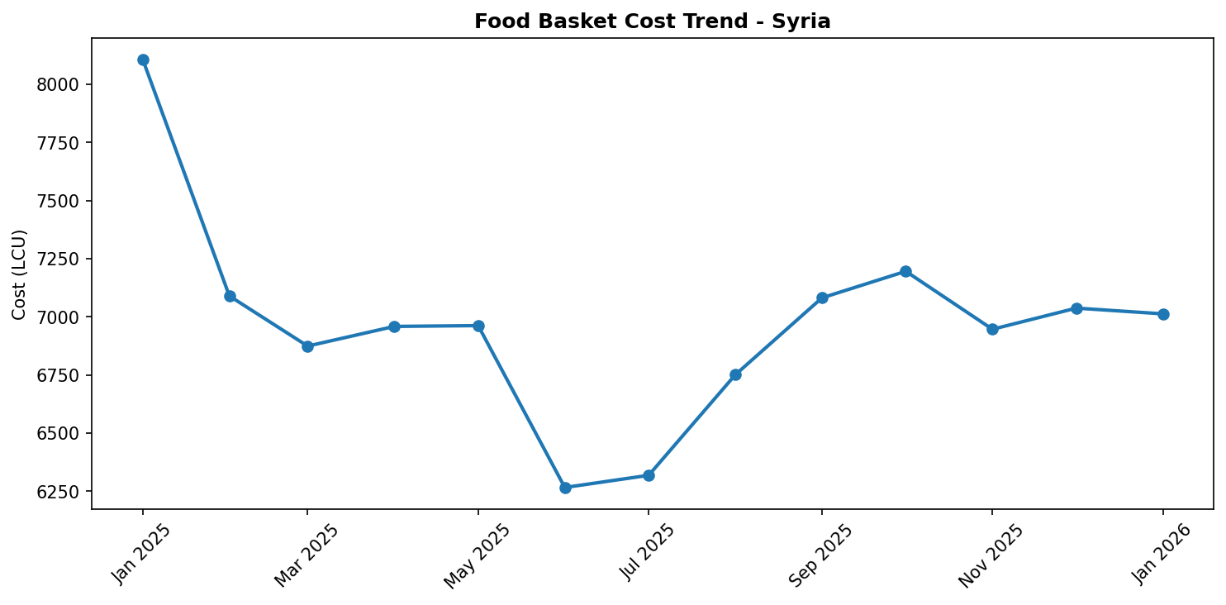
Food basket cost trend

Market Overview
The Syrian market in January 2026 presents a complex and potentially transient picture, characterized by a prevailing trend of decreasing prices for essential commodities. Evident in both the overall food basket and staple items like wheat flour, a deflationary environment appears to be in effect. This downward trajectory is likely driven by a combination of factors, which may include a temporary improvement in supply dynamics or, critically, a significant reduction in consumer purchasing power. However, this immediate stability is overshadowed by severe climate-induced agricultural supply shocks and an escalating humanitarian crisis. Widespread wildfires across western Syria, a vital agricultural heartland, are set to significantly disrupt future yields and supply chains, while a debilitating snowstorm in northern Syria has exacerbated the plight of internally displaced persons (IDPs) and strained humanitarian resources. The market's current deflationary trend is thus highly vulnerable and may prove temporary, as these profound regional events are strong indicators of imminent volatility, localized price spikes, and increased national humanitarian demands in the coming months.

Commodity Analysis
Analysis of key commodities reveals a continued downward pressure on prices, mirroring the broader market trajectory. Wheat flour, a critical staple, has shown a significant year-over-year decrease of 13.5%, underscoring the deflationary environment observed across the food basket. This trend persisted into the current month, with a slight but notable month-over-month decrease of 0.4%. The sustained reduction in wheat flour prices suggests a potential combination of factors at play. It could indicate an improved, albeit possibly fragile, supply situation for this essential commodity. Alternatively, and perhaps more concerningly, it may reflect a further erosion of consumer purchasing power, leading to a reduced effective demand that forces prices down. Other complex market dynamics, including potential subsidies or aid interventions, could also be contributing to this deflationary pattern. Understanding the precise interplay of these drivers is crucial for forecasting future price stability.
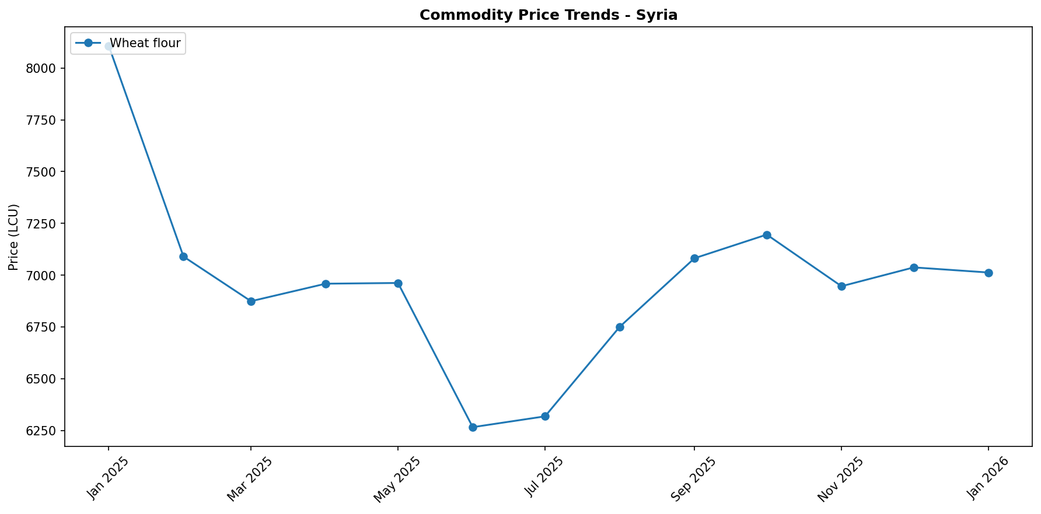
While the current price decrease offers immediate relief in terms of affordability, the underlying causes, particularly reduced purchasing power, point to deepening economic vulnerabilities for Syrian households.

Regional Highlights
Regional disparities and specific climatic events continue to exert significant influence on market conditions and humanitarian needs across Syria. Western Syria, encompassing the governorates of Lattakia, Tartous, Homs, Hama, and Idleb, has been severely impacted by widespread wildfires that erupted in July 2025. These fires have caused extensive damage to agricultural lands, signaling inevitable long-term disruptions to local supply chains and anticipated reductions in crop yields. While national price statistics might not yet fully reflect this, these agricultural losses are highly likely to lead to localized food insecurity and upward price pressure for agricultural products in the medium term, potentially contrasting with the current national downward trend.
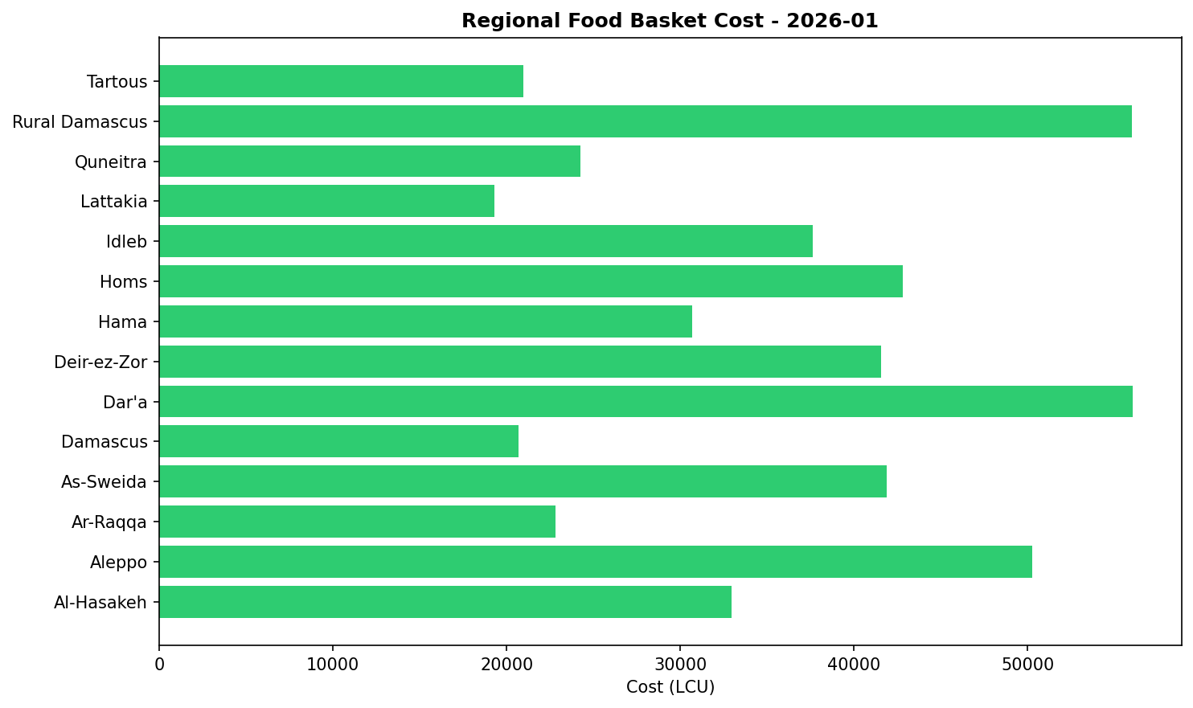
Concurrently, northern Syria, particularly Aleppo, Idleb, and Al-Hasakeh governorates, faced a severe snowstorm in December 2025. This storm critically affected 90 IDP sites, causing two infant deaths in Harim due to extreme cold and damaging approximately 5,000 shelters/tents. This exacerbates an already dire humanitarian crisis, escalating demand for non-food items, heating fuel, and emergency aid. While the direct impact on overall food commodity prices might be less immediate than the wildfires, the storm significantly strains local resources and logistics, increasing the population's vulnerability and indirectly affecting market stability and access to goods.

References
- [rw_4193733] ReliefWeb (2026-01-09) Syrian Arab Republic Fire 2025: DREF Operational Update (MDRSY015), January 2026
https://reliefweb.int/node/4193733
- [rw_4193579] ReliefWeb (2026-01-08) 10 conflictos para tener en la mira en 2026
https://reliefweb.int/node/4193579
- [rw_4193578] ReliefWeb (2026-01-08) 10 Conflicts to Watch in 2026
https://reliefweb.int/node/4193578
- [rw_4193405] ReliefWeb (2026-01-07) UNHCR Yemen Protection Brief 2025
https://reliefweb.int/node/4193405
- [rw_4193357] ReliefWeb (2026-01-06) Syrian Arab Republic: Flash Update No. 1 - Heavy Snowfall Hits Displaced Communities in Northern Syria (as of 6 January 2026)
https://reliefweb.int/node/4193357
- [rw_4193248] ReliefWeb (2026-01-05) Priority countries: Belgium, Germany and Norway’s contributions through the Special Fund for Emergency and Resilience Activities (SFERA)
https://reliefweb.int/node/4193248
- [rw_4193242] ReliefWeb (2026-01-05) QRCS enhances prosthetic, cancer diagnosis services in Syria [EN/AR]
https://reliefweb.int/node/4193242
- [rw_4193196] ReliefWeb (2026-01-05) Winterization Needs Assessment - Idleb and Aleppo Governorates (January 2026)
https://reliefweb.int/node/4193196
- [rw_4193176] ReliefWeb (2026-01-05) Syria Context Report, December 31, 2025
https://reliefweb.int/node/4193176
- [rw_4193078] ReliefWeb (2025-12-31) Syria: Joint Multi-Sectoral Needs Assessment (JMSNA) December 2025
https://reliefweb.int/node/4193078
- [gdelt_c6a8f434] GDELT (20260109) EU Launches New Era in Syria Relations
https://www.miragenews.com/eu-launches-new-era-in-syria-relations-1599747/
- [gdelt_ef70e6df] GDELT (20260109) Israel and Turkey are no longer feuding allies ; they are strategic rivals
https://www.middleeastmonitor.com/20260109-israel-and-turkey-are-no-longer-feuding-allies-they-are-strategic-rivals/
- [gdelt_30435d76] GDELT (20260109) Syria interested in adopting Azerbaijan SME house model [ PHOTO ]
https://www.azernews.az/nation/252762.html
- [gdelt_b8f5c63b] GDELT (20260109) Somaliland recognition : Israel foothold in the Horn of Africa
https://www.yahoo.com/news/articles/somaliland-recognition-israel-foothold-horn-075138163.html
- [gdelt_7e08c963] GDELT (20260109) Somaliland recognition : Israel foothold in the Horn of Africa - Dominican Republic Post – Caribbean News , Business , Travel & Culture
https://dominicanrepublicpost.com/somaliland-recognition-israels-foothold-in-the-horn-of-africa/
- [gdelt_de2abec6] GDELT (20260109) Alexander Gur - Arie : Iranian army could side with people , IRGC more motivated to defend regime – INTERVIEW
https://news.az/news/-alexander-gur-arie-iranian-army-could-side-with-people-irgc-more-motivated-to-defend-regime-interview
- [gdelt_7922f01a] GDELT (20260109) Weekly Sanctions Update : January 7 , 2026
https://www.mondaq.com:443/unitedstates/export-controls-trade-investment-sanctions/1728858/weekly-sanctions-update-january-7-2026
- [gdelt_bc927563] GDELT (20260109) Sanctions Update : January 7 , 2026
https://www.mondaq.com:443/unitedstates/export-controls-trade-investment-sanctions/1728834/sanctions-update-january-7-2026
- [gdelt_6675d091] GDELT (20260109) Roaming Charges : In ICE Cold Blood
https://www.counterpunch.org/2026/01/09/roaming-charges-125/
- [gdelt_d254b9e9] GDELT (20260109) The Region in Brief
https://armenianweekly.com/2026/01/08/the-region-in-brief-152/

